Positioners
1052 Tower
Photo OK
http://www.ets-lindgren.com/datasheet/positioners/antenna-towers/8002/800201 D
http://www.ets-lindgren.com/sites/etsauthor/ProductsManuals/Positioners/1052(1).pdf M
2171 Tower
http://www.ets-lindgren.com/datasheet/positioners/antenna-towers/8002/800202 D
http://www.ets-lindgren.com/sites/etsauthor/ProductsManuals/Positioners/2171B%202170B%20399364%20E.pdf M
2175 Tower
http://www.ets-lindgren.com/datasheet/positioners/antenna-towers/8002/800203 D
http://www.ets-lindgren.com/sites/etsauthor/ProductsManuals/Positioners/2175%20399770%20D.pdf M
Controllers
EM Centre
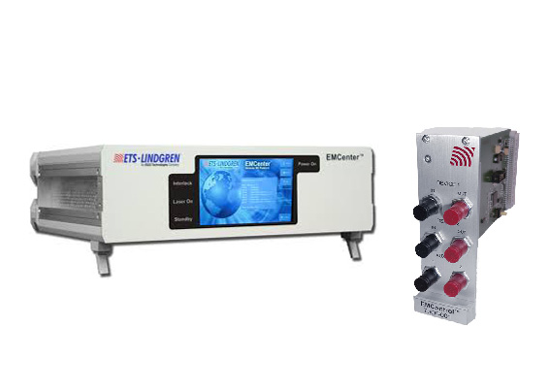
http://www.ets-lindgren.com/datasheet/positioners/controllers/9003/900310 D
EM Control
http://www.ets-lindgren.com/datasheet/positioners/controllers/5010/501002 D
http://www.ets-lindgren.com/sites/etsauthor/SiteCollectionDocuments/Manuals/Positioners/EMControl%20399348%20C.pdf M
Maps
2110CR
http://www.ets-lindgren.com/datasheet/positioners/multi-axis-positioner-(maps)/8003/800302 D
http://www.ets-lindgren.com/sites/etsauthor/ProductsManuals/Positioners/2110CR%202115CR%202120CR%20399308%20E.pdf M

2115CR
http://www.ets-lindgren.com/datasheet/positioners/multi-axis-positioner-(maps)/8003/800303 D
http://www.ets-lindgren.com/sites/etsauthor/ProductsManuals/Positioners/2110CR%202115CR%202120CR%20399308%20E.pdf M
2120CR
http://www.ets-lindgren.com/datasheet/positioners/multi-axis-positioner-(maps)/8003/800301 D
http://www.ets-lindgren.com/sites/etsauthor/ProductsManuals/Positioners/2110CR%202115CR%202120CR%20399308%20E.pdf M
Tripods
4-TR
http://www.ets-lindgren.com/datasheet/positioners/tripods/8005/800501 D
7-TR
http://www.ets-lindgren.com/datasheet/positioners/tripods/8005/800502 D
http://www.ets-lindgren.com/sites/etsauthor/SiteCollectionDocuments/Manuals/Positioners/7-TR(1).pdf M
Turntables
1062-1.2
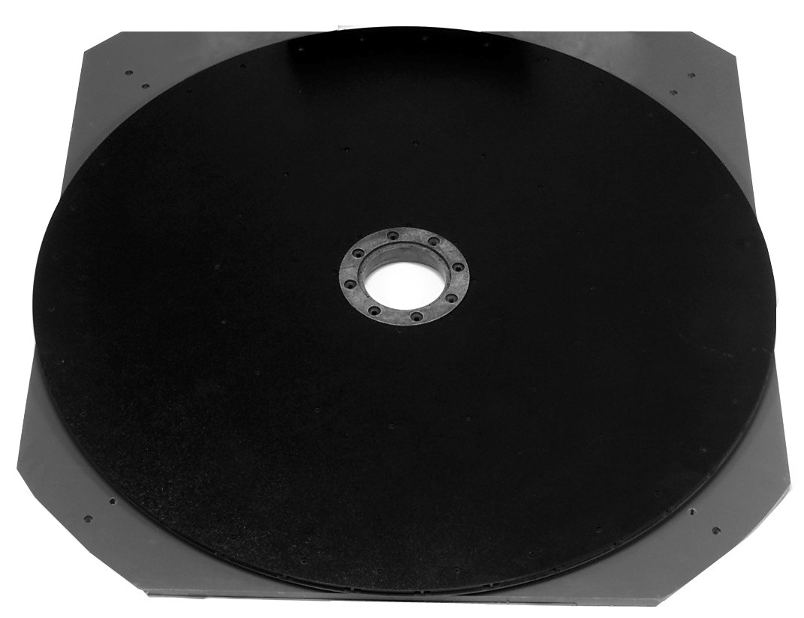
http://www.ets-lindgren.com/datasheet/positioners/turntables/8006/800601 D
2006
http://www.ets-lindgren.com/datasheet/positioners/turntables/8004/800402 D
http://www.ets-lindgren.com/sites/etsauthor/ProductsManuals/Positioners/399410%20Rev%20B_MANUAL_2006%20PRECISION%20AZIMUTH%20POSITIONER.pdf M
2165
http://www.ets-lindgren.com/datasheet/positioners/turntables/8006/800602 D
http://www.ets-lindgren.com/sites/etsauthor/ProductsManuals/Positioners/2165%20399791%20D.pdf M

2187
http://www.ets-lindgren.com/datasheet/positioners/turntables/8006/800604 D
http://www.ets-lindgren.com/sites/etsauthor/ProductsManuals/Positioners/2187%20399789%20D.pdf M
2188
http://www.ets-lindgren.com/datasheet/positioners/turntables/8006/800605 D
http://www.ets-lindgren.com/sites/etsauthor/ProductsManuals/Positioners/2188%20399771%20E.pdf M

