Rohde & Schwarz (HAMEG)
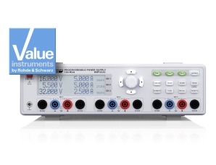
HAMEG HMP2020/2030 Programmable Two/Three-Channel Power Supply
Product Overview
In the HMP series there are two 200 W and two 400 W types available which cover the range of 0...32 V and up to 10 A, depending on the number of channels required. This series is based on a classical concept with a mains transformer, high efficiency electronic pre regulators and linear post regulators. This concept yields the high power in the smallest space with the highest efficiency.
The HMP series further excels by its intelligent power management which allows higher currents (e.g. up to 10 A) at medium voltages (e.g. up to 16 V) to be made available. Excellent low residual ripple voltages (150 µVrms) are realized even at full power output. The high adjustment and back-reading resolution of up to 1 mV/0.1 mA fulfills even the strictest requirements. Last but not least there is the EasyArb function available on all channels which allows you to program simple arbitrary voltage and current waveforms.

Model Selection
Designation | Type
Programmable Two-Channel Power Supply | HAMEG® HMP2020
Programmable Three-Channel Power Supply | HAMEG® HMP2030

Key Features
- HMP2020: 1 × 0 V to 32 V/0 A to 10 A; 1 × 0 V to 32 V/ 0 A to 5 A; max. 188 W
- HMP2030: 3 × 0 V to 32 V/0 A to 5 A; max. 188 W
- 188 W output power through intelligent power management
- Low residual ripple: < 150 μV (RMS) due to linear postregulators
- High setting and read-back resolution of 1 mV up to 0.1 mA
- Galvanically isolated, earth-free and short-circuit protected output channels
- Advanced parallel and serial operation via V/I tracking
- EasyArb function for user-definable V/I characteristics
- FuseLink: individual channel combination of electronic fuses
- User-adjustable overvoltage protection (OVP) for all outputs
- All parameters clearly displayed via LCD/illuminated buttons
- Rear connectors for all channels, including sense
- USB/RS-232 interface, optionally Ethernet/USB or IEEE 488 (GPIB)

