• ABSORBER NESTED DUAL-POLARIZED DUAL-VIVALDI ARRAY ANTENNA 3165-01 Absorber Nested Dual-Polarized Dual-Vivaldi Array Antenna
​ETS-Lindgren's Model 3165-01 Absorber Nested Dual-Polarized Dual-Vivaldi Array Antenna is designed for applications where source antenna effects must be minimized, such as chambers where the device under test (DUT) is illuminated from different directions.​
- 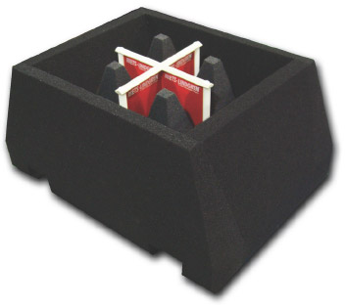
• ​ETS-Lindgren's Model 3165-01 Absorber Nested Dual-Polarized Dual-Vivaldi Array Antenna is designed for applications where source antenna effects must be minimized, such as chambers where the device under test (DUT) is illuminated from different directions.
Key Features  - • 700 MHz to 6 GHz Frequency Range  - Low Reflectivity  - Dual Linearly Polarized  - Low VSWR with High Directivity  - Multiple Mounting Schemes | Features  ​Frequency Range  The model 3165-01 has a frequency range of 700 MHz to 6 GHz, which covers most cell phone, Wi-Fi, WiMA​​​​X and GPS bands.  Low Reflectivity  This antenna is designed to be nested in the anechoic absorber lining of a chamber. Installed in this configuration, the model 3165-01 antenna exhibits very low reflectivity, even when the input ports are mismatched. The normal incidence reflectivity is approximately -40 dB for a majority of the frequency range.  Dual-Linear Polarization  The model 3165-01 is a dual-linearly polarized antenna, capable of measuring two orthogonal components of the field simultaneously.  Low VSWR and High Directivity  The model 3165-01 possesses very low VSWR, while maintaining high directivity. This allows use in the illumination of DUTs, without affecting adjacent antennas in a multi-antenna installation.

Specifications

Electrical Specifications
Frequency Minimum: 700 MHz
Frequency Maximum: 6 GHz
Cross Polarization Isolation: >25 dB
Maximum Continuous Power: 5 W
Connectors: (2) SMA Female
Impedance: 50 Ω
Pattern Type: Directional
Polarization: Dual-Linear

Physical Specifications

​Model | Aperture Height​ | ​Aperture Width | ​Length | ​Width
​3165-01-MG​ | ​17.8 cm (7.0 in) | ​19.0 cm (7.5 in) | ​19.0 cm (7.5 in)​ | ​1.3 kg (2.9 lb)
​3165-01-SQ​ | ​35.5 cm (14.0 in)​ | ​35.5 cm (14.0 in) | ​36.3 cm (14.3 in) | ​2.6 kg (5.8 lb)​
​3165-01-RD​ | ​35.5 cm (14.0 in)​ | ​35.5 cm (14.0 in)​ | ​36.3 cm (14.3 in) | ​2.6 kg (5.8 lb​)

Other Specifications
- Antenna Including the Selected Mounting (Specify when Ordering):​
  - MG - Magnetic Mount
  - SQ - Mounts to 50.8 mm (2 in x 2 in) Square Tube
  - RD - Mounts to 50 mm (1.96 in) Round Pipe
- Individually Calibrated at 1 m per the SAE ARP 958

Product Charts
​